A Dark, Dark Tale

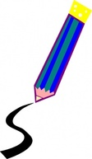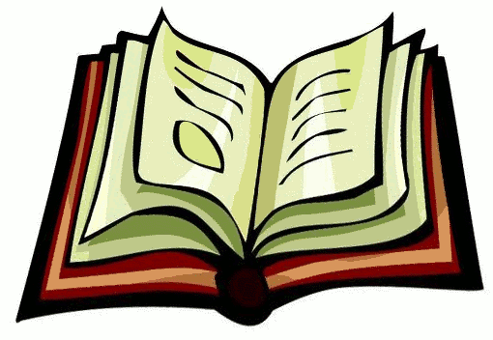
Draw your favourite part of the story.

I liked it when ______________________________
____________________________________________________________________________________________________________________________________________________________________

